Exp 3: Spectrum Analysis of Sub-1 GHz, Mid-band & mm Wave by Plotting Propagation Loss.
AIM: To analyze the propagation loss characteristics of different frequency bands (Sub-1 GHz, Mid-band, and mm Wave) in wireless communication systems and compare their performance over varying distances using MATLAB.
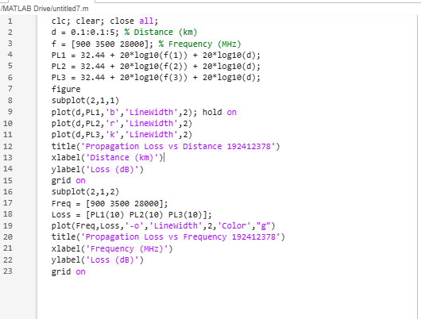
Objective : 1 To compute the Propagation Loss (dB) for Sub-1 GHz, Mid-band, and mmWave
frequency ranges using standard path loss models.

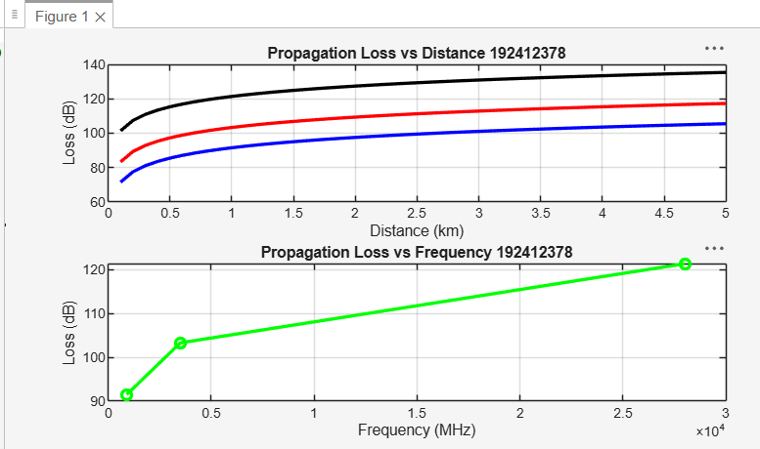

Objective 2. To evaluate the impact of different Operating Frequencies (GHz) on signal attenuation and coverage performance.
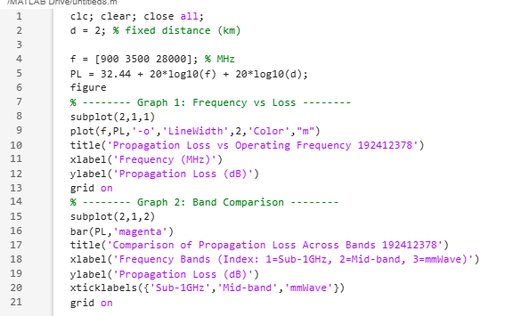

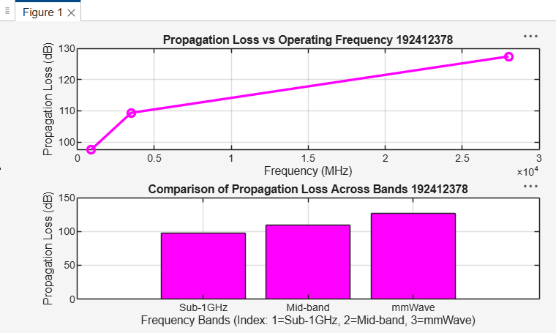

Objective 3. To analyze how Communication Distance (km) affects propagation loss across different spectrum bands.
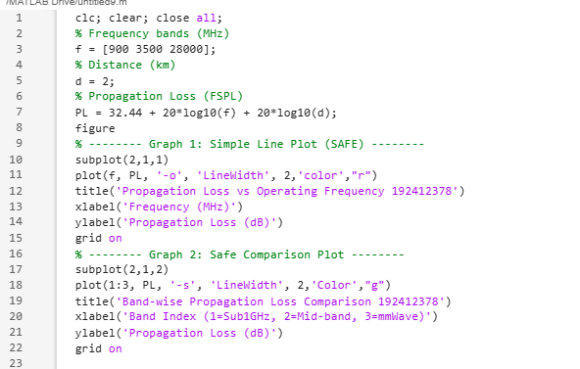

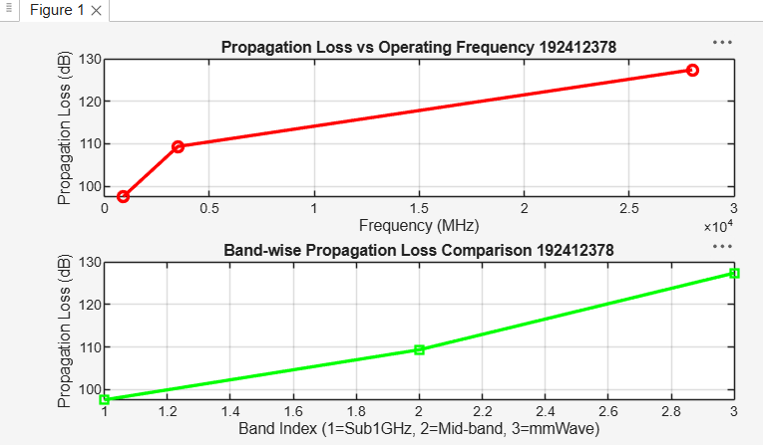

Result:
1. The propagation loss was successfully computed for Sub-1 GHz, Mid-band, and
Mm Wave frequency bands using the Free Space Path Loss (FSPL) model.
2. It was observed that propagation loss increases with increase in operating frequency, with
Mm Wave showing the highest attenuation and Sub-1 GHz showing the lowest loss.
3. The comparative analysis of spectrum bands clearly demonstrates that lower frequency
bands are more suitable for long-range communication, while higher frequency bands
require advanced techniques like beamforming for efficient performance.

